THE RIDE OF SILENCE

Ever hear of us? If yes, awesome, then you know what we do and why we do it. If no, this is who we are and what we are about:

WHY DOES THE RIDE OF SILENCE ORGANIZATION EXIST?
* To HONOR those who have been injured or killed
* To RAISE AWARENESS that we are here
* To ask that we all SHARE THE ROAD

Hundreds of cyclists are killed or injured each year. This national ride is to honor those that have been killed.

The ride is free and open to all ages. Helmets must be worn and blinking lights are recommended. There is no registration. All you have to do is show up. The ride is a funeral type procession, up to 12 miles long with an approximate average
pace of 10-12 mph. You can have as many as 2, 5, 10, 1000+ people ride.

The Ride of Silence headquarters is located in Garland, TX with Board members located in Michigan, Florida and New Jersey. We have organizers throughout the United States, Canada and the World.

If you have never been a part of a Ride of Silence, please make it part of your list of things to do in 2017.

​Mark your calendars, if you haven't already, for Wednesday, May 17, 2017 and help us get the word out about the ride to your family, friends and co-workers by organizing a ride in your area.

It’s easy to organize a ride. You can put as much effort into organizing your ride as you want. We do request that you inform your local police department and have them come out and support the ride.

To see if there is already a ride organized in your area, please click on this link:
http://www.rideofsilence.org/locations-domestic.php

Click on your state.

If your state or an area close by is not listed, please organize a ride (details do not have to be finalized until April, 2017).

Please click on this link:
http://www.rideofsilence.org/addlocation.php

Fill out the information requested and your ride will be added to the list of registered rides – (the link above). Get the word out to your friends, family and cycling buddies to join you on this most solemn night to honor cyclists like ourselves who have been injured or killed by motorists.

The Ride of Silence is a 501 (c) 3 tax exempt, non-profit organization.

“Alone we are but a whisper, together we shall speak loudly through a Silence that will resonate around the world.”
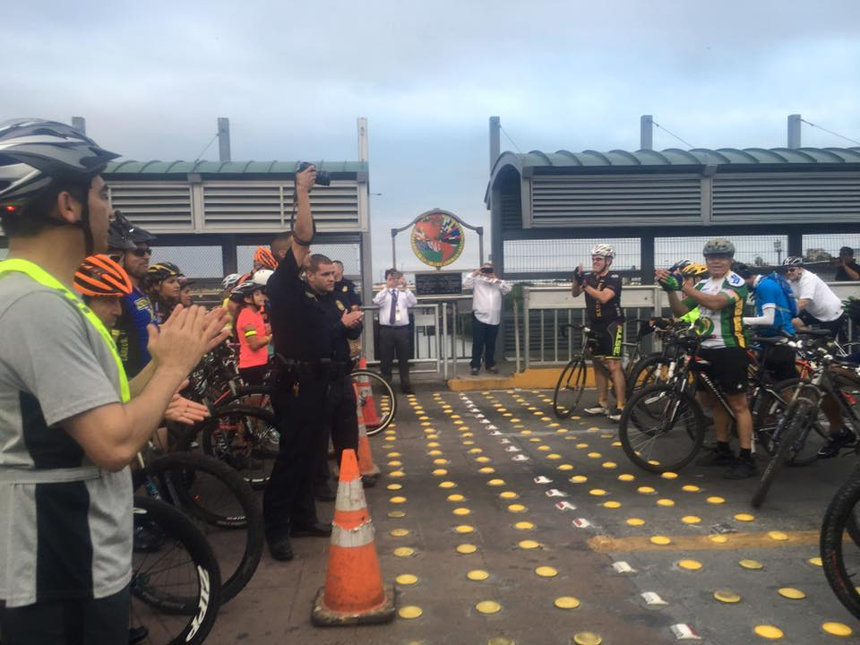

Laredo Texas & Nuevo Laredo Mexico met at the border.

http://www.rideofsilence.org
For more information contact Debbie at secretary@rideofsilence.org

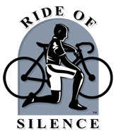

The 2016 Ride Of Silence:
445 locations worldwide,
50 states, 48 countries,
7 continents,
0 words spoken,
A million powerful memories

