Who Rode Worldwide in 2014?  Antarctica, Australia, Bolivia, Brazil, Canada, China, Colombia, Cyprus, Hong Kong, Israel, Lebanon, Malaysia, Mexico, Panama, the Philippines, Romania, Singapore, Spain, Sweden, Taiwan, Uganda and the U. S. A.  Some Locations That Participated:  Antarctica - Palmer Station, 12 Spinners  Bellevue NE USA, 170 Riders  Belo Horizonte Brazil, 152 Ciclistas  Bloomington IL USA, 200 Riders  Boston MA USA, 60 Riders  Cleremont FL USA, 275 Riders  Columbia SC USA, 160 Riders  Dallas TX USA, 700 Riders  Detroit MI USA, 200 Riders  Guangzhou China, 12 Qí zìxíngchē  Hong Kong, 830 Qí zìxíngchē  Indianapolis IN USA, 0 Riders (rained-out)  Kailua Kona HA USA, 73 Riders  Kungsbacka Sweden, 62 Cyklists  Lafayette LA USA,100 Riders  Laval QC Canadá, 202 Bicyclistes  Manley NSW Australia, 90 Riders  Marikina City Philippines, 268 Ciclistas  Montpelier VT USA, 27 Riders  Niagara Falls ON Canada, 50 Riders  Nicosia Cyprus, 167 Bisikletçis  Oshawa ON Canada, 16 Riders  Philadelphia PA USA, 175 Riders  Ridgetown ON Canada, 25 Riders  Penang Malaysia, 100 Riders  Repentigny QC Canadá, 275 Bicyclistes  Rochester NY USA, 95 Riders  Sacramento CA USA, 135 Riders  Toronto ON Canada, 50 Riders  Wagga Wagga NSW Australia, 28 Riders  Washington DC USA, 0 Riders (rained-out) | 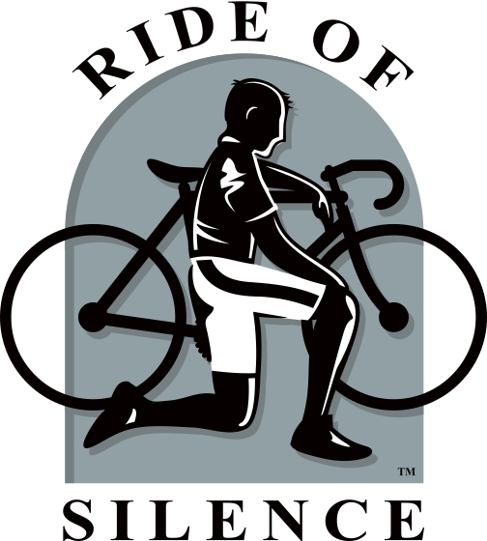  Join thousands of cyclists worldwide on Wed. May 20th, 2015 in the N. Hemisphere, Sat. May 23rd, in the S. Hemisphere.  The Ride of Silence is a FREE ride that honors cyclists who’ve been injured or killed by motorists while riding on public roadways.  It allows us the opportunity to raise  awareness of cyclist’s rights to the road,  to let motorists and the public know they must SHARE the ROAD with us.  Rides in the N. Hemisphere start at 7 PM, please arrive by 6:30.  Rides in the S. Hemisphere start at 10 AM, please arrive by 9:30.  ** Helmets are Mandatory **  Headlights and taillights are highly recommended, but not required.  Red & Black armbands may be provided.  (see inside for local ride info) |  |  | Why Did We Ride?  Green Valley AZ USA:  ”To remember the life of Albert Rich, who recently graduated from the high school. While cycling in Tucson was struck and killed by a semi-truck in July of last year.”  Belo Horizonte Brazil:  “Também mencionamos e lembramos do nosso amigo Thomas de Danbury/USA.”  (Also mentioned and remember our friend Thomas, from Danbury [CT] USA.)  Dunedin FL USA:  “We dedicated the event to Rob Lemon and Hilary Michalak, the young couple tragically struck down on Clearwater Memorial Causeway in the early morning hours of Labor Day 2013 while riding their tandem.”  Wagga Wagga NSW Australia:  “...listened to the RoS Poem. This was followed by a minute's silence while the gathered cyclists remembered their friends and loved ones that have died or been injured as a result of close encounters of the worst kind with vehicles.”  22  Fort Worth TX USA:  “The spirits of Megan Baab and Iris Stagner were very much present. Even though our hearts mourn for those we’ve lost, we ride joyfully, to honor their memory.”  LOCAL RIDE INFO:
Why Did We Ride? – Continued:  Laval QC Canada:  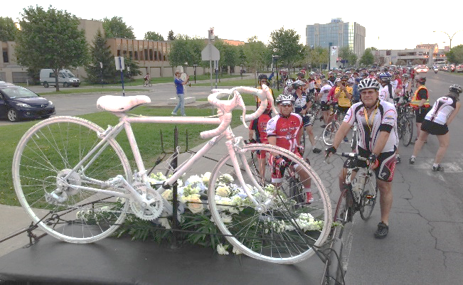  Danbury CT USA:  “Kayte Steinert-Threlkeld also spoke; her husband Tom was killed last year while on a recreational ride. Tom is the only known RofS organizer to have been killed while cycling”  Unique Things To Each Ride:  Palmer Station Antarctica:  “12 of the 19 people on station participated in the RoS in the gym. We rode for 1 hour and split our volunteers into 2 groups so that way we had 2 people cycling at once.”  Franklinville-Williamstown NJ USA:  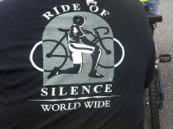  Davis CA USA:  “We ended at the US Bicycling Hall of Fame, where we had refreshments and the opportunity finally to talk among ourselves.” |  | Woodland Park CO USA:  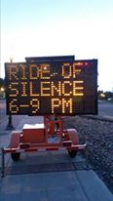  Menominee MI / Marinette WI USA:  “We are the only Ride whose course goes through  2 cities and 2 states!”  Las Vegas NV USA:  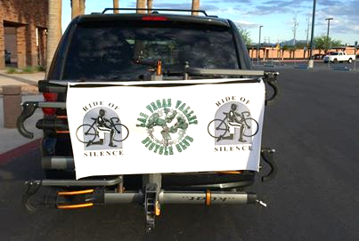  Ridgetown ON Canada:  “Our group was primarily our 4-H Bike Club participants and their family and friends. The majority of participants were aged 10-12.”  Huntersville NC USA  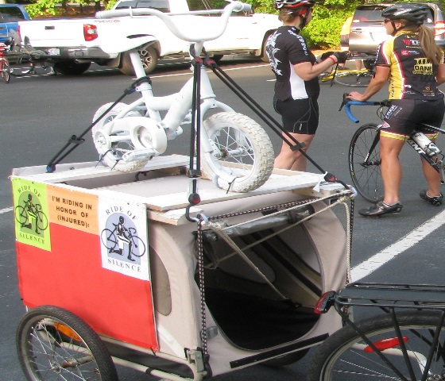 | Saint Paul MN USA:  Repentigny QC Canada:  “Our President of Honor was Joannie Rochette, Olympic Skater…”  Nicosia Cyprus:  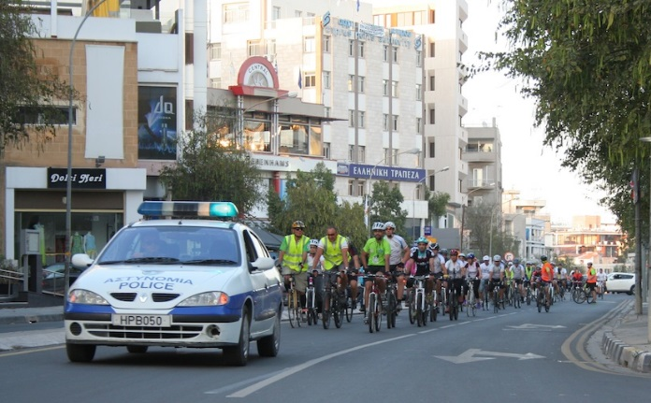  RIDE OF SILENCE POEM:  Today we number many but ride as one  In honor of those not with us,  friends, mothers, fathers, sisters, sons  With helmets on tight and heads down low,  We ride in silence, cautious and slow  The wheels start spinning in the lead pack  But today we ride and no one attacks  The dark sunglasses cover our tears  Remembering those we held so dear  Today’s ride is to make others aware  The road is there for all to share  To those not with us or by our side,  May God be your partner on your final ride.  by Mike Murgas  http://www.rideofsilence.org

