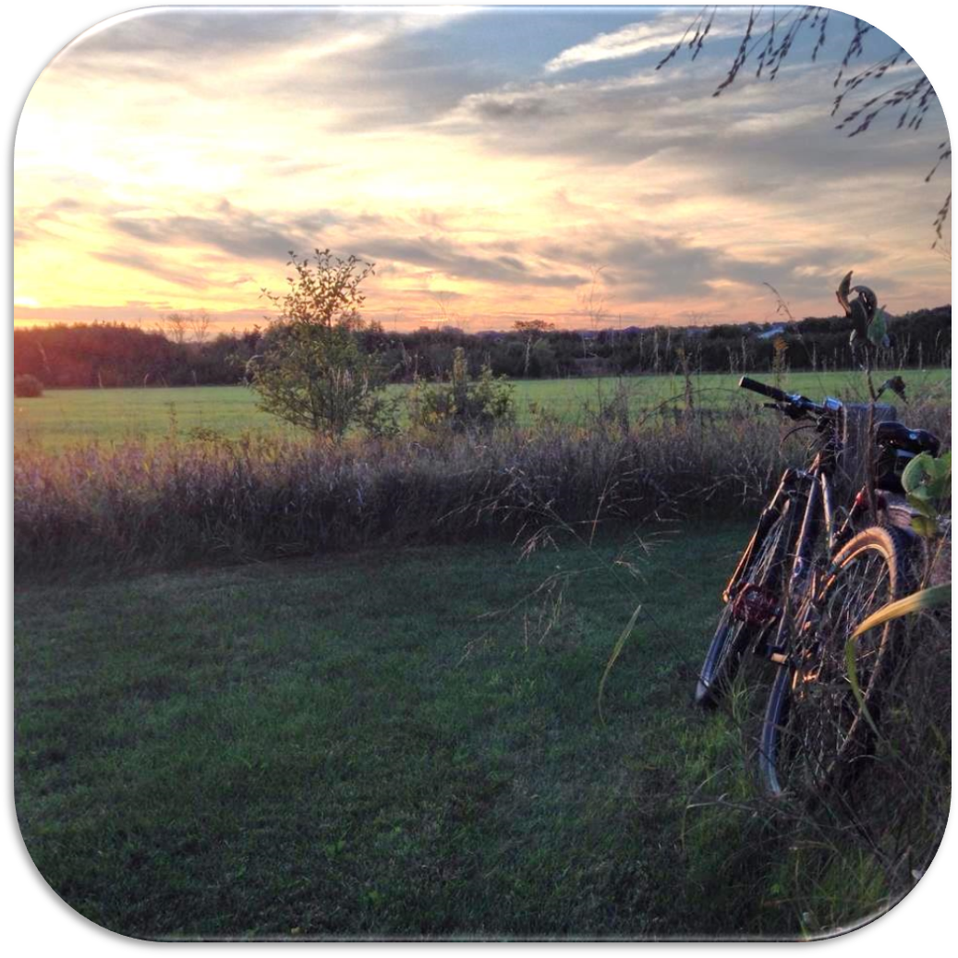
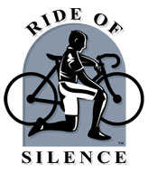

Why Do We Ride?
To HONOR those who have been injured
or killed while cycling
To RAISE AWARENESS that we are here
To ask that we all SHARE THE ROAD

“Alone we are but a whisper, together we shall speak loudly through a Silence that will resonate around the world.”

The ride is FREE and open to everyone. Helmets must be worn
Route is 10 miles long and pace will be 10-12 mph

Date: May 18, 2016

Time: 7:00 PM - Please arrive by 6:30 PM

Place: ENTER YOUR INFORMATION HERE

Tonight we number many but ride as one
In honor of those not with us…
The dark sunglasses cover our tears
Remembering those we held so dear
Tonight's ride is to make others aware
The road is there for all to share
To those not with us or by our side,
May God be your partner on your final ride

