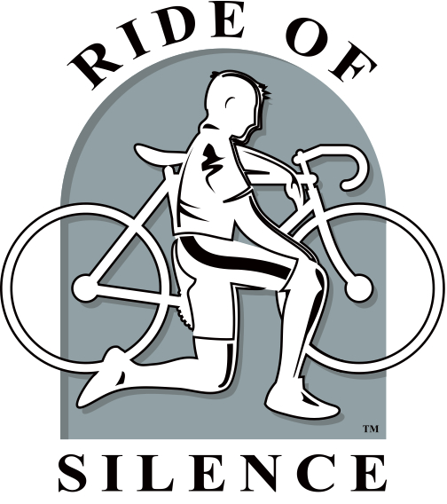  2018 Holland Ride of Silence  (hundreds of locations worldwide)  FREE ride raising awareness of cyclists rights to the public roadways  May 16th, 7:00 PM  (arrive by 6:30)  Holland Civic Center Parking Lot  150 W 8th st near picnic tables.  7 miles, no faster than 12 MPH, in Silence. HPS Support.  Helmets are required, Lights are strongly recommended.  Contact: Mark Hagar – 616.422.9871  mark.hagar@rideofsilence.org |  | 2018 Holland Ride of Silence  (hundreds of locations worldwide)  FREE ride raising awareness of cyclists rights to the public roadways  May 16th, 7:00 PM  (arrive by 6:30)  Holland Civic Center Parking Lot  150 W 8th st near picnic tables.  7 miles, no faster than 12 MPH, in Silence. HPS Support.  Helmets are required, Lights are strongly recommended.  Contact: Mark Hagar – 616.422.9871  mark.hagar@rideofsilence.org |  | 2018 Holland Ride of Silence  (hundreds of locations worldwide)  FREE ride raising awareness of cyclists rights to the public roadways  May 16th, 7:00 PM  (arrive by 6:30)  Holland Civic Center Parking Lot  150 W 8th st near picnic tables.  7 miles, no faster than 12 MPH, in Silence. HPS Support.  Helmets are required, Lights are strongly recommended.  Contact: Mark Hagar – 616.422.9871  mark.hagar@rideofsilence.org

